K-12 Report Cards Update: June 2023
Dear Parents and Caregivers,
With this being the last report card of this school year, I wanted to provide you with some information about the exciting changes to report cards and how student learning will be communicated to you next school year.
You may remember getting a letter grade or percentage at the end of a chapter in your textbook or after a test, signaling to you that learning had come to an end. Today we know that learning doesn’t stop when students hand in an assignment or complete a test. That’s why students in Kindergarten to Grade 9 will receive marks on a four-point proficiency scale, instead of receiving letter grades starting in the new school year. Students in Grades 10-12 will still receive a letter grade and percentage to support their entry into post-secondary education. Report cards for all students will now also include self-reflection and goal setting, as well as descriptive feedback.
What do these changes mean for the next school year?
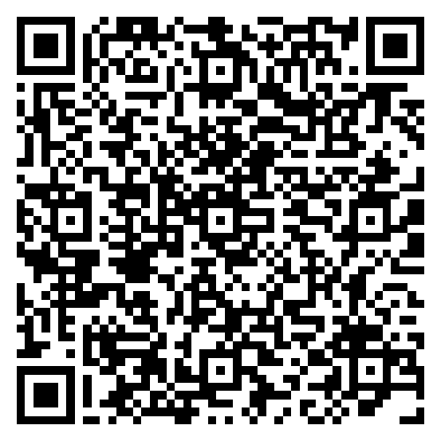
These changes mean that report cards may not look the same as when you were in school or may look different from what you received for your child this year. However, you can trust that the information you will receive will provide a complete picture of what your child can do, where they need to improve, and how you can support their learning.
You’ll be provided with more information on the changes to report cards next school year, in the fall. Until then, you can learn more about the changes on the Ministry of Education and Child Care’s website by going to www.gov.bc.ca/StudentReportingForFamilies, following the QR code, or by reviewing the attached report card changes overview document. Our school district has also released materials to support the report card changes for families in our school community. These materials are available at ___________.
What can you expect?
Communications between home and school will continue to play an important role in helping students thrive. The changes to report cards that are being introduced have been developed with teachers and administrators and are based on modern, quality practices in reporting. These changes will ensure that you have the information you need to understand how your child is doing, as well as opportunities to help them continue to learn and grow.
If you have any questions on these changes, please reach out to _________________ for further information.
As we have reached the end of the 2022/23 school year, I want to wish you and your child a happy and restful summer.
Sincerely,
Superintendent or Principal

